PHARMACOGNASTIC STUDY AND DEVELOPMENT OF QUALITY CONTROL PARAMETERS FOR FLOWERS OF ĀVARTAKĪ (CASSIA AURICULATA LINN).
S.Sankaraiah¹, Dr. Renu Dixit², Dr. K. V. Vijaya Bhaskara Reddy³
¹PG scholar, Dept. of Dravyaguna, S.V. Ayurvedic Medical Collage, Tirupati, Andhra Pradesh, India.
²Associate Professor , PG Dept of Dravyaguna, S.V. Ayurvedic Medical Collage, Tirupati, Andhra Pradesh, India.
³Associate Professor, PG Dept. of Shalya Tantara, S.V. Ayurvedic Medical Collage, Tirupati, Andhra Pradesh, India.
Corresponding Author
¹S.Sankaraiah
Email: sri.sankar007@gmail.com
Ph.No. 9700770255
ABSTRACT
Context: Āvartakī (Cassia auriculata linn) flowers are used for various conditions of ailments in traditional systems of medicine since ancient times.

Aims: This study is designed to lay down the various pharmacognostic and phytochemical standards which will be helpful to ensure the purity, safety, and efficacy of this medicinal plant.

Materials and Methods: Various methods including macroscopic, microscopic, physicochemical and phytochemical methods were applied to determine the diagnostic features for the identification and standardization of intact and powdered drug of Āvartakī (Cassia auriculata Linn) flowers.

Results: The shape, color, odour and surface characteristics were determined for the intact drug and powdered materials of Āvartakī (Cassia auriculata Linn) flowers. Light and electron microscope images of cross-section of stamen and powdered microscopy revealed useful diagnostic features. Phytochemical, physicochemical analysis of powdered drug proved useful to differentiate the powdered drug material. High performance thin layer chromatography analysis showed the presence of important phytoconstituents.

Conclusion: Morphology as well as various pharmacognostic aspects of different parts of the plant were studied and have been described here along with phytochemical and physicochemical studies, which will help in authentication and quality control.
Key words: Pharmacognostic, Physicochemical, Phytochemical, Standardization, Āvartakī (Cassia auriculata Linn) flowers.
------------------------------------------------------------------------------------------------------------
INTRODUCTION:
The word 'Pharmacognosy' is derived from two Greek words 'Pharmakon', 'a drug', and ‘gignosco’, 'to acquire a knowledge'. It may be defined as "an applied science which deals with the biological, biochemical and economical features of natural drugs and their constituents." In a restricted sense, it implies particular knowledge of methods of identification and evaluation of drugs ⁽¹⁾.
Medicinal plants form the major part of the raw materials used by the Ayurvedic practitioners. Most of the books dealing with the Materia medica of Ayurveda, the correct identity of the botanical source has become very difficult on account of the synonyms and the use of vernacular names⁽²⁾. For this, a scientific investigation of the medicinal plants embodying proper identification of all source plants and correlating them properly to the drugs described in Ayurvedic literature is absolutely necessary. A full account of the details of gross morphology and anatomy of a drug along with microscopical study is also necessary. This can be possible only by the study of pharmacognosy.
Quality control of crude plant drugs is the other major problem faced by the Ayurvedic system of medicine. The therapeutic efficacy is absolutely dependent on the quality of the plant drug used. And if the plant drugs are adulterated, the quality of the preparation cannot go up to the standard level. For this proper identification of plants and raw materials at the basic level with the help of microscopic and morphological characteristics is essential. The identification of adulterants from crude plant drugs and powdered drugs is also essential. For this, various pharmacognostic standards may be applied to standardize and maintain the 'quality control' of the single plant drugs. Though pharmacognostic standards alone may not always be adequate to ensure their quality but can play a major role to standardize a plant drug.
Keeping the above views in mind the pharmacognostical study of Cassia auriculata Linn. was carried out in Sugen life science, Pvt. Ltd. S.V Nagar, Tirupati, analysis report No. 23115-17.
MATERIAL AND METHODS:

Plant material
The trail drug Āvartakī puṣpa for the study were acquired from Tirupati surrounding places. For the present study the fresh drug was taken and it was later dried in shade. After drying it was pounded to coarse powder. Powdered drug was stored in an air tight and light resistant container for the study.

Macroscopic studies⁽³⁾
Macroscopic and organoleptic studies were conducted on intact and powdered materials. Sample was washed, air dried in shade and observed for color, shape, odor, taste, and other surface characteristics. Flowers which were shade dried for 10–15 days after drying it was pounded to coarse powder and observed for color, odor, taste.

Microscopic studies⁽⁴⁾
Morphological examinations were conducted using a binocular zoom light microscope, semi plan achro (Model AxL, LABO, Germany). Cross-sections were prepared by free hand sectioning cleared with chloralhydrate, stained with freshly prepared dyes safranin and fast green, and different grades of alcohol were used to increase visibility. All the images presented were taken by the author using digital camera.

Physicochemical analysis⁽⁵⁾

Total ash and acid insoluble ash contents are important indices to determine quality and purity of herbal medicines.
- Loss on drying at 105° C/Moisture content
10 gm of trail drug samples are placed after accurately weighing it in a tarred evaporating dish. After placing the above said amount of sample in a tarred evaporating dish is dried at 105° C for 5 hours and it is weighed. After drying tarred evaporating dish was allowed to cool in desiccators for 30 minutes and then weighed the remnant material.

Difference in weight after heating
The % of Loss on drying = ----------------------------------------- x 100
Weight of sample taken

Determination of Ash
- Determination of Total Ash
About 2.0g of powdered drugs was weighed and placed in three separate previously ignited and tarred silica crucibles. The samples were spread evenly and then ignite or incinerate it to a constant temperature not exceeding 450°C until it is white indicating the absence of carbon. The crucible then cooled in desiccators and final weighed. The results were then calculated the content of total ash in terms of percentage w/w of the air-dried drug.
- Determination of Extractable Matter in water and alcohol
About 4.0g of coarsely powdered air dried samples, was accurately weighed in three glass Stoppard conical flask and macerated with 100ml of the solvent (Water, Methanol, Ethanol, Hydro alcoholic, Ethyl acetate, Chloroform, Benzene and Hexane) specified for the plant material concerned for 6 hours, shaking frequently and then allowed to stand for 18 hours. Filtering was done by whatman paper, taking care not to lose any solvent, and then transfer 25 ml of filtrate to tarred flat bottomed shallow dish. The extracted matter was dried at 105°C for 6 hours, cooled in a desiccators for 30 minutes and then weighed. The percentage extractable matter was calculated.

Preliminary phytochemical screening ⁽⁵⁾
The Phytochemical study is necessary to understand the basic component of drug which may help to construct the hypothetical action of the trail drug in the disease. Each and every drug has its own physicochemical characteristic which are like finger prints helping in Identifying the drug and isolating it from the closely related drugs of the speices.
I. Tests for Alkaloids
  - Mayer's Test: To1 ml of the extract, 3 ml of Mayer's reagent was added, the formation of full white precipitate confirmed the presence of alkaloids.
II. Test for Carbohydrates
- Molisch Test: To 2 ml of the extract, 1 ml of α-naphthol solution and concentrated sulphuric acid through the sides of test tube were added. Purple or reddish violet colour at the junction of the two liquids revealed the presence of carbohydrates.
III. Tests for Proteins and Amino Acids
- Lead Acetate Test: To the extract, 1ml of lead acetate solution is added. Formation of a white precipitate indicated the presence of proteins.
IV. Tests for Phytosterol
- Salkowski Test: Dissolve the extract in chloroform and equal volume of concentrate sulphuric acid. Formation of bluish red to cherry red colour in chloroform layer and green fluorescence in the acid layer represented the steroid components in the tested extract.

VI. Test for Saponins
- About 1 ml of methanol extract was diluted separately with distilled water to 20 ml, and shaken in a graduated cylinder for 15 minutes. 1cm layer of foam indicated the presence of saponins.
VII. Test for Flavonoids
- Shinoda Test: To 1 ml of the extract, magnesium turnings were added followed by 1-2 drops of concentrated hydrochloric acid. Formation of red colour showed the presence of flavanoids.
VIII. Test for Tannins and Phenolic compounds
  - To 1 ml of the extract, ferric chloride was added, formation of a dark blue or greenish black colour product showed the presence of tannin.

High Performance Thin Layer Chromatography⁽⁶⁾
High performance thin layer chromatography (HPTLC) is an enhanced form of thin layer chromatography (TLC). A number of enhancements can be made to the basic method of thin layer chromatography to automate the different steps, to increase the resolution achieved and to allow more accurate quantitative measurements. The HPTLC study of the powdered drug of Āvartakī puṣpa was executed at S.D.M Centre for Research in Ayurveda and allied sciences. UDIPI (Karnataka). Analysis Report No. 806/16090101
1g sample was extracted with 10 ml of alcohol. 3.6 and 9 µl of Āvartakī puṣpa cūrṇam extract was applied on a pre-coated silicagel F254 on aluminium plates to a band width of 7mm using Linomat 5TLC applicator. The plate was developed in toluene: Ethyl Acetate (8:2). The developed plates were visualized in Short UV, Long UV, and then derivatised with vanillin sulphuric acid and scanned under Short UV and Long UV. Rf, colour of the spots and densitometry scan were recorded.
RESULTS

Macroscopic characters
- Organoleptic Properties:
Āvartakī flowers was Yellow colour, Characteristic odour, Astringent and Bitter tast and bright yellow and large (nearly 5 cm across), the pedicels glabrous and 2.5 cm long.
- Macroscopic characters:
Irregular, bisexual, bright yellow and large (nearly 5 cm across), the pedicels glabrous and 2.5 cm long. The racemes are few-flowered, short, erect, and crowded in axils of upper leaves so as to form a large terminal inflorescence (leaves except stipules are suppressed at the upper nodes). The 5 sepals are distinct, imbricate, glabrous, concave, membranous and unequal, with the two outer ones much larger than the inner ones. The petals also 5 in number, are free, imbricate and crisped along the margin, bright yellow veined with orange. The anthers number 10 and are separate, with the three upper stamens barren; the ovary is superior, uni-locular, with marginal ovules.
- Microscopic characters :
Pedicel-Shows ridges and furrows in outline with a single layered epidermis having a
few unicellular hairs; cortex composed of a wide zone of collapsed, thin walled, parenchymatous cells having a few oil globules; collateral vascular bundle and secretory cells are present; pith consisting of thin-walled, oval to polygonal, parenchymatous cells; irregular, elongated, lignified stone cells isolated or in groups, having narrow lumen and pits, found in cortex and pith.
Sepal- Single layered epidermis, slightly sinuous in surface view, present on both 15
surfaces, a few unicellular hairs are in outer surface; ground tissue composed of thin walled, oval to polygonal, parenchymatous cells having a few prismatic crystals of calcium oxalate; a few vascular bundles present in ground tissue.
Petal-Epidermis single layered of rectangular cells, slightly sinuous in surface view,
present on both surfaces; a few fibro-vascular bundles present in ground tissue along
with a few cluster crystals of calcium oxalate.
Powder Analysis:
- Raw Powder:
- Organoleptic Properties:
Āvartakī puṣpa cūrṇa was Brownish yellow colour, Characteristic odour, Astringent (kashaya) and Bitter (tikta) taste and Chopped pieces.
- Microscopic characters :
Powder - Dark-brown; shows fragments of parenchymatous cells, broken unicellular
hairs, vessels with spiral thickening, a few prismatic and cluster crystals of calcium
oxalate; a few irregular shaped, elongated, lignified, stone cells with narrow lumen in
singles or groups; fairly large circular to spherical, brown coloured, numerous smooth
pollen grains measuring 67-82 µ in dia. having clear exine and intine and a few oil
globules.

PHARMACOGNOSTIC STUDY OF ĀVARTAKĪ PUṢPA
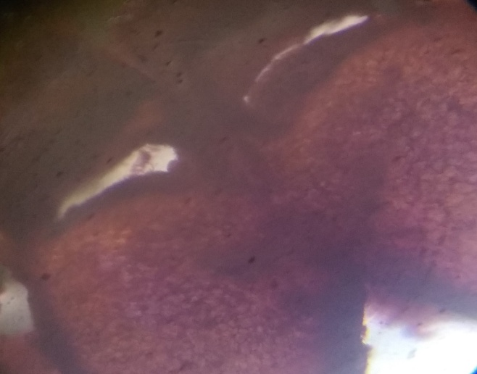 | 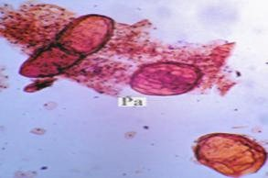
FIG. 1.T.S of Stamen | FIG 2. Parenchymatous cells
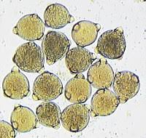 | 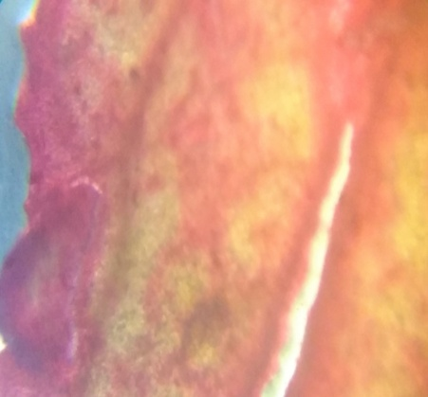
FIG. 3. Pollen grains cells | FIG.4. Petal at 10x magnification
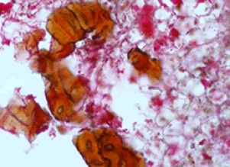 | 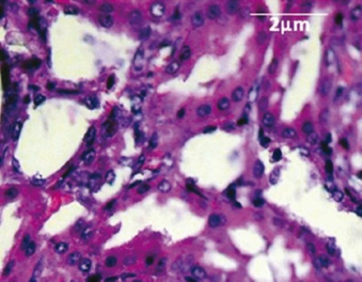
FIG 5. Stone cells | FIG 6. Calcium oxalate cells

Determination of physicochemical parameters
This physic-chemical properties of Āvartakī puṣpa cūrṇa in the parameters of Foreign matter, Loss on drying, Total ash, Alcohol-soluble extractive, Water- soluble extractive values were 0.44%w/w, 6.5%w/w, 7.5% w/w, 0.99% w/w, 5.33%w/w respectively.

Preliminary phytochemical and histochemical screening
The preliminary Phytochemicals was done in the department and following results obtained. It was noticed that Āvartakī puṣpa cūrṇa with aqueous mixture has the presence of Carbohydrates, Saponins, Tanins, Proteins, Amino acids and Steroids and pH of was found to be 6, which is mild acidic.
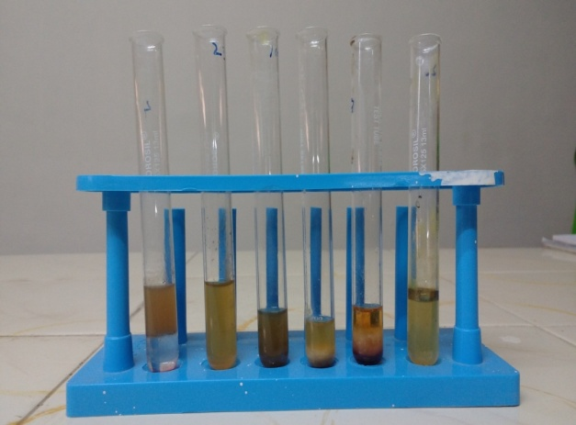 | 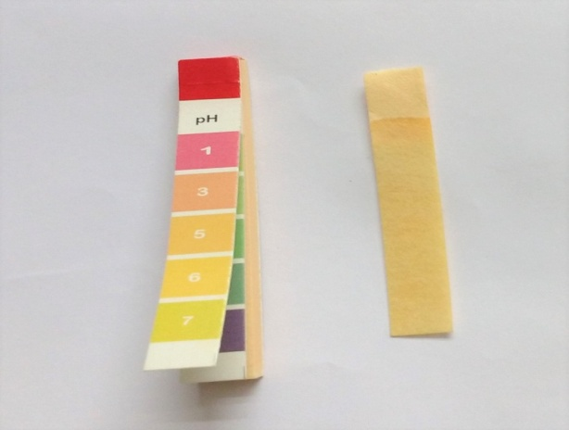
Phytochemical study of Aqueous extract of Āvartakī flower | pH of Aqueous extract of Āvartakī flower

High Performance Thin Layer Chromatography
The HPTLC of Āvartakī flower powder showed the following results , at short UV (254nm) there were four bands observed with Rf of 0.03, 0.12, 0.22, 0.59 with different intensities of green, at long UV (366nm) 11 spots were observed with Rf values of 0.03,0.06, 0.12, 0.18 (with different fluorescent intensities of green) 0.24,0.30, 0.44, 0.61, 0.69, 0.77, 0.89 (with different fluorescent intensities of red), after derivatization with vanillin sulphuric acid there were 7 spots observed (with various color intensities of violet) 0.14, 0.16, 0.32, 0.47, 0.56, 0.65, 0.73.
Densitometric scan at 254nm shows 9 spots with Rf 0.02 (has maximum area of 30.70%), 0.06 (area of 26.78%), 0.15 (has maximum area of 24.72%), at 366nm densitometric scan showed 8 spots with Rf 0.06 (which had maximum area 58.62%), at 620nm following derivatisation there were 9 spots observed with Rf 0.03 (with maximum area of 42.76%) was more prominent.

HPTLC photo documentation of ethanolic extract of Āvartakī puṣpa chūrnam

At Short UV | At Long UV | After Derivtisation

track 1-Āvartakī puṣpa chūrnam– 3 µl
track 2-Āvartakī puṣpa chūrnam– 6 µl
track 3-Āvartakī puṣpa chūrnam– 9 µl
Figure 1.Densitometric scan at 254 nm
Āvartakī puṣpa chūrnam (9 µl)

Figure 2.Densitometric scan at 366nm
Āvartakī puṣpa chūrnam(9 µl)

Figure 3.Densitometric scan Afterderivatisation
Āvartakī puṣpa chūrnam (9 µl)

DISCUSSION:
This study is an attempt to establish, the diagnostic characteristics of Āvartakī (Cassia auriculata Linn). These results can be employed as suitable quality control measures to ensure the quality, safety and efficacy of this herbal drug material. The parameters studied here are useful to identify and authenticate the traditionally important medicinal plant Āvartakī (Cassia auriculata Linn) and this will prove helpful in the preparation of herbal monographs and pharmacopoeial standards as emphasized by WHO.
Quality control of crude plant drugs is the other major problem faced by the Ayurvedic system of medicine. The therapeutic efficacy is absolutely dependent on the quality of the plant drug used. And if the plant drugs are adulterated, the quality of the preparation cannot go up to the standard level. For this proper identification of plants and raw materials at the basic level with the help of microscopic and morphological characteristics is essential. The identification of adulterants from crude plant drugs and powdered drugs is also essential. For this, various pharmacognostic standards may be applied to standardize and maintain the 'quality control' of the single plant drugs. Though pharmacognostic standards alone may not always be adequate to ensure their quality but can play a major role to standardize a plant drug.
The Phytochemical study is necessary to understand the basic component of drug which may help to construct the hypothetical action of the trail drug in the disease. Each and every drug has its own physicochemical characteristic which are like finger prints helping in Identifying the drug and isolating it from the closely related drugs of the speices. Hence, phytochemical analysis of the drug using various test parameters helps in standardizing the drug and to authenticate the sample. HPLC analysis may serve as a useful data for the standardization of the drug.
The data generated from this study would help in the authentication of various parts of Cassia auriculata Linn, a very important constituent of various herbal drug formulations. Since API (Ayurveda pharmacopeia of India) 7 volumes doesn’t incorporated the macroscopic and microscopic, Physico-chemical properties and HPTLC. This study becomes very important in the field of standardization of the drug. This study will be useful in feature for the identification and measure of purity, standardization of Cassia auriculata Linn. to the researches working in this field. This may lead to easier authentication of herbal drugs procured from markets for the correct identification of the medicinal plant ingredients.
CONCLUSION
The macro and microscopic study of flower is quite accurate. The important thing that was observed in the raw powder of flowers showed a few prismatic and cluster crystals of calcium oxalate, numerous smooth pollen grains measuring 67-82 µ in dia. having clear exine and intine and a few oil globules and presence lignified, stone cells.
The physicochemical characters shows the total ash 7.5% w/w which may be due to the presence of calcium oxalate crystals. Loss on drying 6.5% w/w is may be due to the more moisture content in the flowers. Looking into the Alcohol and water soluble extractive values 0.99% w/w and 5.33% w/w respectively. We can infer that the water extract value is more, so the drug and its chemical constituents water soluble. Phytochemical study shows that Āvartakī puṣpa cūrṇa with aqueous mixture has the presence of Carbohydrates, Saponins, Tanins, Proteins, Amino acids and Steroids and pH was found to be 6, which is mild acidic. HPTLC study showed 4 bonds at short UV 11 spots at long UV and after determination with after derivatization with vanillin sulphuric acid there were 7 spots observed in various colour intensities. Densitometric scan at showed 9 spots at 254nm, 8 spots at 366nm and after at 620 nm 9 spots.
The data generated from this study would helps in the authentication of Āvartakī (Cassia auriculata linn) flowers, an important constituent of various herbal drug formulations. The qualitative and quantitative microscopic features would prove useful for laying down pharmacopoeial standards. Morphology as well as various pharmacognostic aspects of different parts of the plant were studied and have been described here along with phytochemical, physicochemical studies, which will help in authentication and quality control.
References
- Trease, G. E. and Evan, W. C. Pharmacognosy. 12th edition, English Language Book Society, Balliere, Tindall. (1983).
- Khory and Katrak , Material medica of India and their therapetics.1 st ed. Bombay; Neeraj publishers; 1989.p.198
- Trease, Evans. Text Book of Pharmacognosy. 15th ed. Delhi, India: Elsevier Publisher; 2009.
- Geneva: WHO; 2002. WHO. Quality Control Method for Medicinal Plant Materials.
- Khandelwal. K. R, Practical Pharmacognosy, Nirali Prakshan Publishers.
- Dr. C. K. Kokate, Pharmacognosy, 50th Edition, Nirali Prakashan Publisher, 2014.
- Nayak BS, Patel KN. Pharmacognostic studies of the Jatrophacurcas leaves. Int J PharmTech Res. 2010;2:140–3.

